VKhUTEMAS (Vysshie Khudozhestvenno-Tekhnicheskie Masterskie—Higher Art and Technical Studios) was the school of arts and architecture in Moscow between 1920 and 1927. Similar “art and technical studios” existed in other Soviet cities. VKhUTEMAS was supervised by Narkompros (the ministry of culture), particularly by the commissar (minister) of culture Anatolii Lunacharskii and became the center of developing and propagating modernism in Soviet Russia.
VKhUTEMAS emerged as a result of post-Revolutionary reconstruction of a preexisting system of art education: it replaced Moscow Svomas (Svobodnye gosudarstvennye khudozhestvennye masterskie—Independent State Art Studios), which, in turn, was formed in 1918 on the base of the pre-Revolutionary Stroganov Art School (First Free Art Studio) and the Moscow School of Painting, Sculpture, and Architecture (Second Free Art Studio). Likewise, in 1927 VKhUTEMAS did not disappear, but was restructured and renamed as VKhUTEIN (Vysshii Khudozhestvenno-Tekhnicheskii Institut—Higher Art and Technical Institute), which in 1930 was once again reorganized into several institutions. VKhUTEMAS and VKhUTEIN were headed by painter and sculptor Efim Ravdel’ (1920-1923), graphic artist Vladimir Favorskii (1923-1926), and critic Pavel Novitskii (1926-1930).
The pedagogical system and the modernist experimentation that took place at VKhUTEMAS made critics compare it with the BAUHAUS, and indeed, the two schools maintained a connection and exchanged exhibitions and delegations (in particular, during the directorship of HANNES MEYER at the Bauhaus). However, towards the late 1920s VKhUTEMAS became significantly larger than the Bauhaus (for instance, 1445 students studied at VKhUTEMAS in 1923); unlike the Bauhaus, it prepared not only designers, but also artists, sculptors, and architects.
VKhUTEMAS consisted of several departments (their number changed from five to eight), which were subdivided into “fine arts” (Painting, Sculpture, and Architecture), and “industrial” (Textile, Graphics, Metal- and Woodwork, Ceramics) ones. As formulated in the Soviet government decree that proclaimed the creation of VKhUTEMAS, the main task of the institution was preparing specialists for Soviet industry (industrial designers). This programme of “industrial art” [proizvodstvennoe iskusstvo] was particularly favoured and developed by the first rector Ravdel’ and by Constructivist artists, who insisted on defying the old separation of art from life. In reality, however, most VKhUTEMAS students preferred studying fine arts and low enrollment into industrial departments had always remained a problem for VKhUTEMAS pedagogues. In spite of their efforts in the field of industrial design, the most significant achievements of VKhUTEMAS were its new approaches to form-making, which were connected to preliminary theoretical courses rather than design workshops.
Similarly to the Bauhaus Vorkurs system, at the beginning of their education all students at VKhUTEMAS were required to take several introductory, so-called propaedeutic, courses, which provided them with formal principles for future work, and which were based on connecting each art discipline with a formal element dominant for it (the so-called “objective method”): “Colour” (developed by Constructivists LIUBOV’ POPOVA and ALEKSANDR VESNIN) served as an introduction to painting, “Volume” (developed by Cubist sculptor Boris Korolev)—to sculpture, “Space” (developed by the Rationalist architect NIKOLAI LADOVSKII)—to architecture, and “Drawing” (that is, line)—as an introduction to graphic design. The most developed of the introductory courses, Ladovskii’s course “Space,” analyzed three-dimensional reality as a combination of “elements of sensation”: the basic physical, geometrical, and spatial properties of form, such as mass, volume, gravity, or dynamics.
Whereas, initially, Constructivism flourished within the Painting Department, already at the end of 1921 the Constructivist pedagogues of VKhUTEMAS (Rodchencko, Popova, Vesnin and Lavinskii) moved to the positions of PRODUCTIVISM and concentrated their work in the “industrial” (design, as opposed to “fine arts”) departments, in particular, in Metal- and Woodwork (the two departments existed separately until 1926, when they were united; TATLIN taught a course on the “Culture of Material,” Rodchenko—on the “Design of Metal Equipment and Reinforcement,” LISSITZKY, in 1926-1930—on furniture design). As a result of the move of the Constructivists to industrial departments, painting was left to more conservative artists, and indeed, already in 1922-1924 the Department of Painting was taken over by the proponents of easelism. Most of the professors of painting in the mid-1920s were previously connected to the exhibition society “The Knave of Diamonds,” which in 1910-1917 promoted Primitivisim, Cezannism, and Neo-Impressionism in Russia (Petr Konchalovsky, Aleksandr Kuprin, Il’ia Mashkov, Aleksandr Os’merkin, Robert Fal’k).
The Department of Architecture, although technically belonging to fine arts, in reality occupied a middle position between fine and industrial disciplines. In the early 1920s (at the time when the Constructivists actively taught at the Department of Painting), the Architecture Department was dominated by the traditionalists (the first three architectural workshops were headed by ZHOLTOVSKII, SHCHUSEV, and Ivan Ryl’skii). However, by the mid-1920 it replaced Painting as the centre of modernist experimentation at VKhUTEMAS. In 1920, Ladovskii, Nikolai Dokuchaev, and Vladimir Krinskii opened the first modernist architectural studios (the so-called United Left Studios, or Obmas). MEL’NIKOV and GOLOSOV maintained a joint studio from the early 1920s, and Aleksandr Vesnin opened his Constructivist studio in 1924.
During his rectorship in 1923-1926, Favorskii’s tried to overcome the split between fine art and industrial departments. Thus, before enrolling into a particular department, all students had to pass through a course of education at the Basic Department [Osnovnoe otdelenie], which brought together introductory courses that had previously been taught separately, providing formal artistic background for all disciplines.
The dissolution of VKhUTEIN in 1930 was motivated by an urge to tie art and design education to industry. Thus, the Basic Department was eliminated as non-practical, whereas other departments were transferred to institutions that specialized according to types of industrial production, such as the Moscow Architectural Institute, Moscow Textile Institute, and Moscow Institute of Graphic Design (all of which continue to exist today), while the departments of Painting and Sculpture were relocated to Leningrad.

Selected References:
L. I. Ivanova-Veen, O. M. Ziuskevich, T. V. Lysova, Ot VKhUTEMASa K MARKhI, 1920-1936: Arkhitekturnye Proekty Iz Sobraniia Muzeia MARKhI, Moskva: A-Fond, 2005.
Selim Khan-Magomedov, VHUTEMAS. Edition du Regard, Paris 1990. Vols. 1-2.
Selim Khan-Magomedov, VKhUTEMAS: Vysshie gosudarstvennye khudozhestvennye masterskie. Arkhitektura. Derevo. Metall. Keramika. Grafika. Zhivopis’. Skul’ptura. Tekstil’. Moskva: Lad’ia, 1995. Vols, 1-2.
Catherine Cooke, Russian Avant-Garde: Theories of Art, Architecture, and the City, Academy Editions, 1995.

Visual Material:
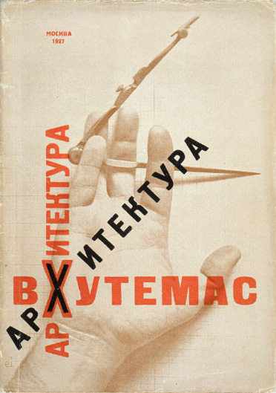
Arkhitektura VKhUTEMAS [Architecture [at] VKhUTEMAS]. Book cover by El Lissitzky, 1927.
http://en.wikipedia.org/wiki/File:Vkhutemas.jpg
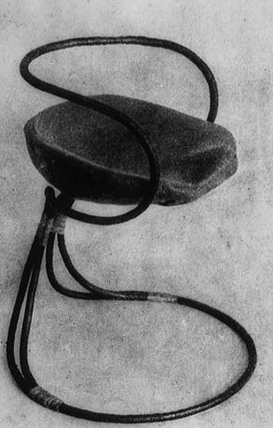
Tubular steel chair designed in Tatlin's atelier at Vkhutein, 1927
http://en.wikipedia.org/wiki/File:Vkhutein.jpg
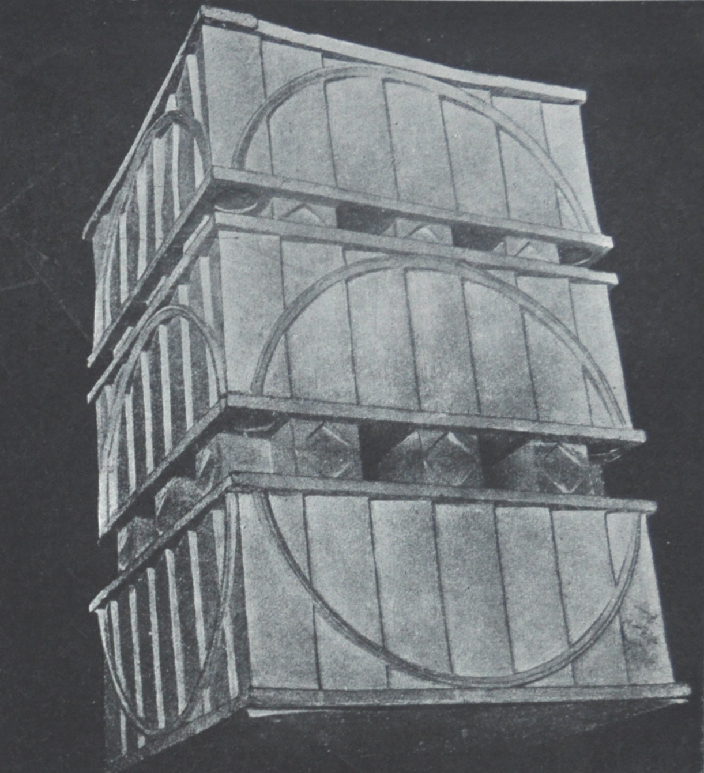
V. A. Petrov, Assignment on the Expression of Form. Ladovskii Workshop, 1920. Published in: Arkhitektura VKhUTEMAS. Raboty arkhitekturnogo fakul’teta VKhUTEMASa. Moskva: Izdanie VKhUTEMASa, 1927, 1.
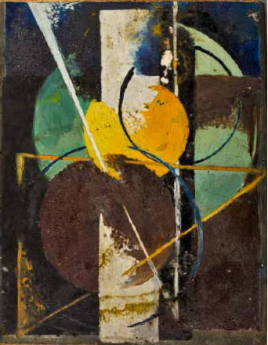
Mikhail Kuznetsov, Color space on a plane. Abstract composition, 1921. “Color” course of Vesnin and Popova. Published in: L. I. Ivanova-Veen (ed.),VKhUTEMAS/VKhUTEIN. Uchebnye raboty. 1920-1930. Moskva-Leningrad. Moskva: Pechatnyi dom, 19.
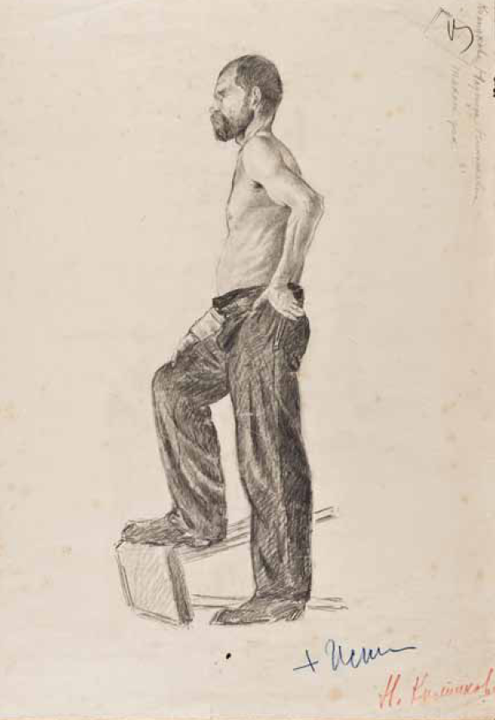
Nadezhda Kolpakova, Model. Entrance examination drawing for the course “Drawing,” 1926. Published in: L. I. Ivanova-Veen (ed.),VKhUTEMAS/VKhUTEIN. Uchebnye raboty. 1920-1930. Moskva-Leningrad. Moskva: Pechatnyi dom, 49.

